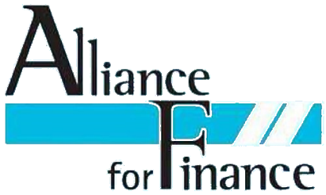

Regional Secretary
Unite The Union
Unite Gibraltar
Transport House
43/45 Town Range
Gibraltar
Date: 12 December 2017

Dear Regional Secretary

Unite Finance & Legal Branch Affiliation

Dear Regional Secretary

Let me introduce the Alliance for Finance to you. We are a confederation of trade unions and employee representative bodies exclusively working in the financial services industry. Our affiliate's members work across all aspects of the financial services industry.

We regularly met with industry bodies and policy makers. In January we shall be meeting with Nicky Morgan MP Chair of the Treasury Select Committee, UK Finance and the Banking Standards Board, with future meetings planned with the FCA and Building Societies Association. Every time we meet with these organisations we the interests and needs of working people in financial services is top of our agenda. We regularly seek the views of our affiliates on issues which they want us to raise direct on their behalf.

In addition to the work which we do to campaign for finance workers rights and protection is our annual program of seminars. We organise and hold around three to four seminars each year on topics which are of interest or affect people working in financial services.

2018 is an exciting year for us, we're working closely with the Chartered Bankers: Professional Standards Board and Banking Standards Board to influence policy to ensure that people working in financial services can be proud of their profession.

Our seminar program for 2018 includes examining the increased use of Artificial Intelligence and Automation in Financial Services, Gender Pay Equality and as many of you know all too well, its 10 years since the financial crisis we'll be looking at what the past 10 years has been like and whether our industry has learnt any lessons. We are pleased to attract a high level of speakers for our events which shows the level of industry wide respect that the Alliance for Finance has with speakers such as Tim Page TUC Senior Policy Officer for Economic and Industrial Policy, Alistair Darling former Chancellor, Professor Phil Taylor Strathclyde University and Professor Gregor Gall of Bradford University. Our seminars are arranged around the UK to allow our affiliate members every opportunity to attend.

All of our seminars are FREE for affiliated members.

We'd like to ask that ciculate our letter to finance branches within your region and Regional Officials with responsibility for the finance and legal sector to encourage local Unite Finance Branches affiliate to the Alliance for Finance. Branch Affiliation fees range from £16.50 to £50 per year depending on the size of their branch. Affiliated member can send as many delegates to our seminars absolutely FREE. I'm sure you will agree that this is great value for money.

For more information about the Alliance for Finance why not visit our website http://www.alliance4finance.org

for information about who your branch can affiliate visit http://www.alliance4finance.org/joining.html

Unite Branches can contact me by email at secretary@alliance4finance.org should they have any questions regarding affiliating.

Kind regards and in solidarity.

Russell Greig
Secretary
Alliance for Finance

